

Assignment 7

CS 432 Spring 2017



March 29, 2017

Michelle Graham

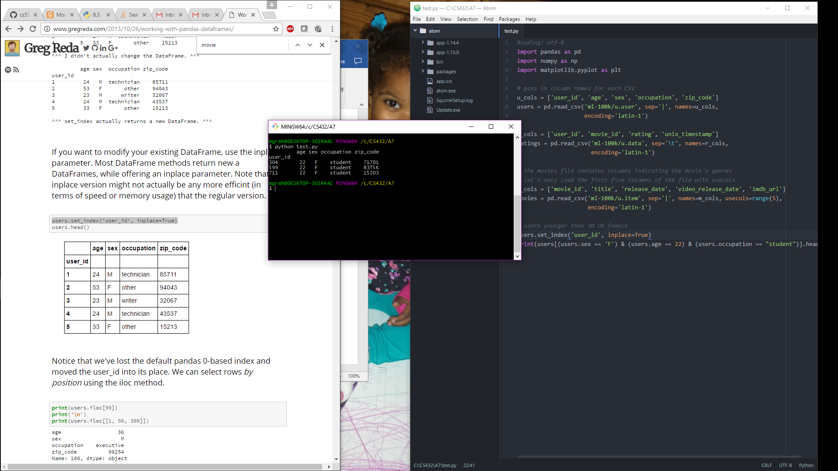

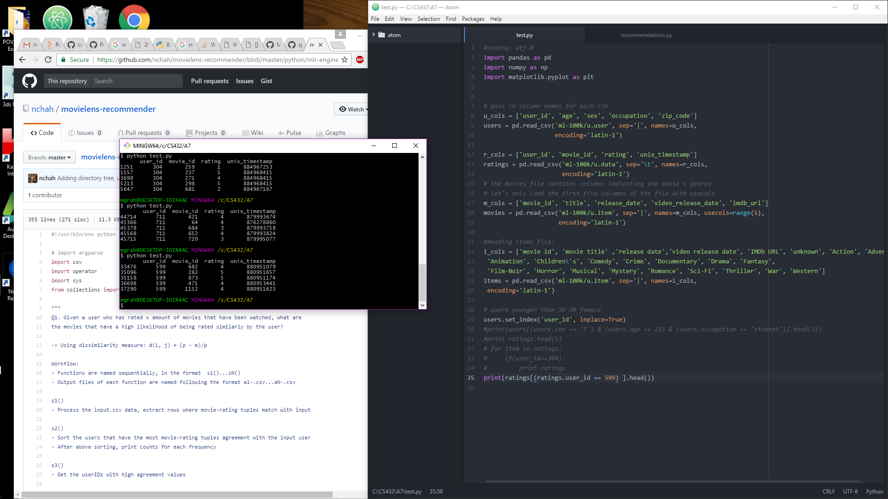

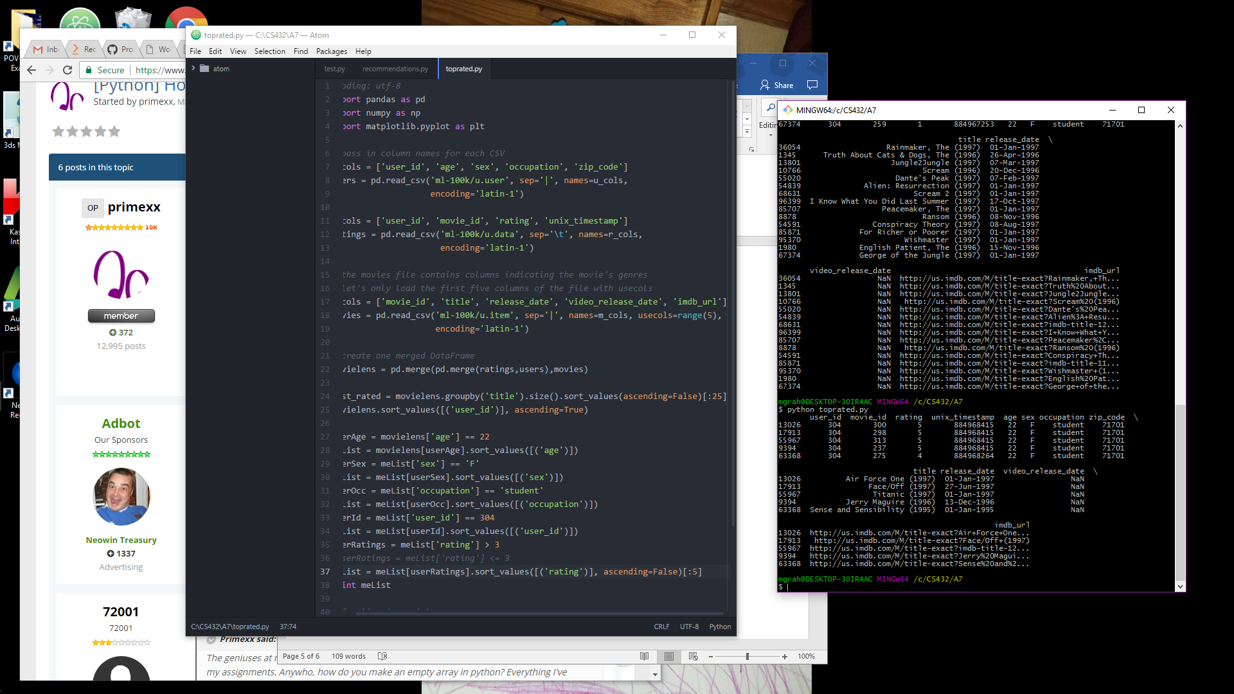



**User 304’s Top 5 Movies:**

Movie Rating

Air Force One (1997) 5

Face/Off (1997) 5

Titanic (1997) 5

Jerry Maguire (1996) 5

Sense and Sensibility (1995) 4

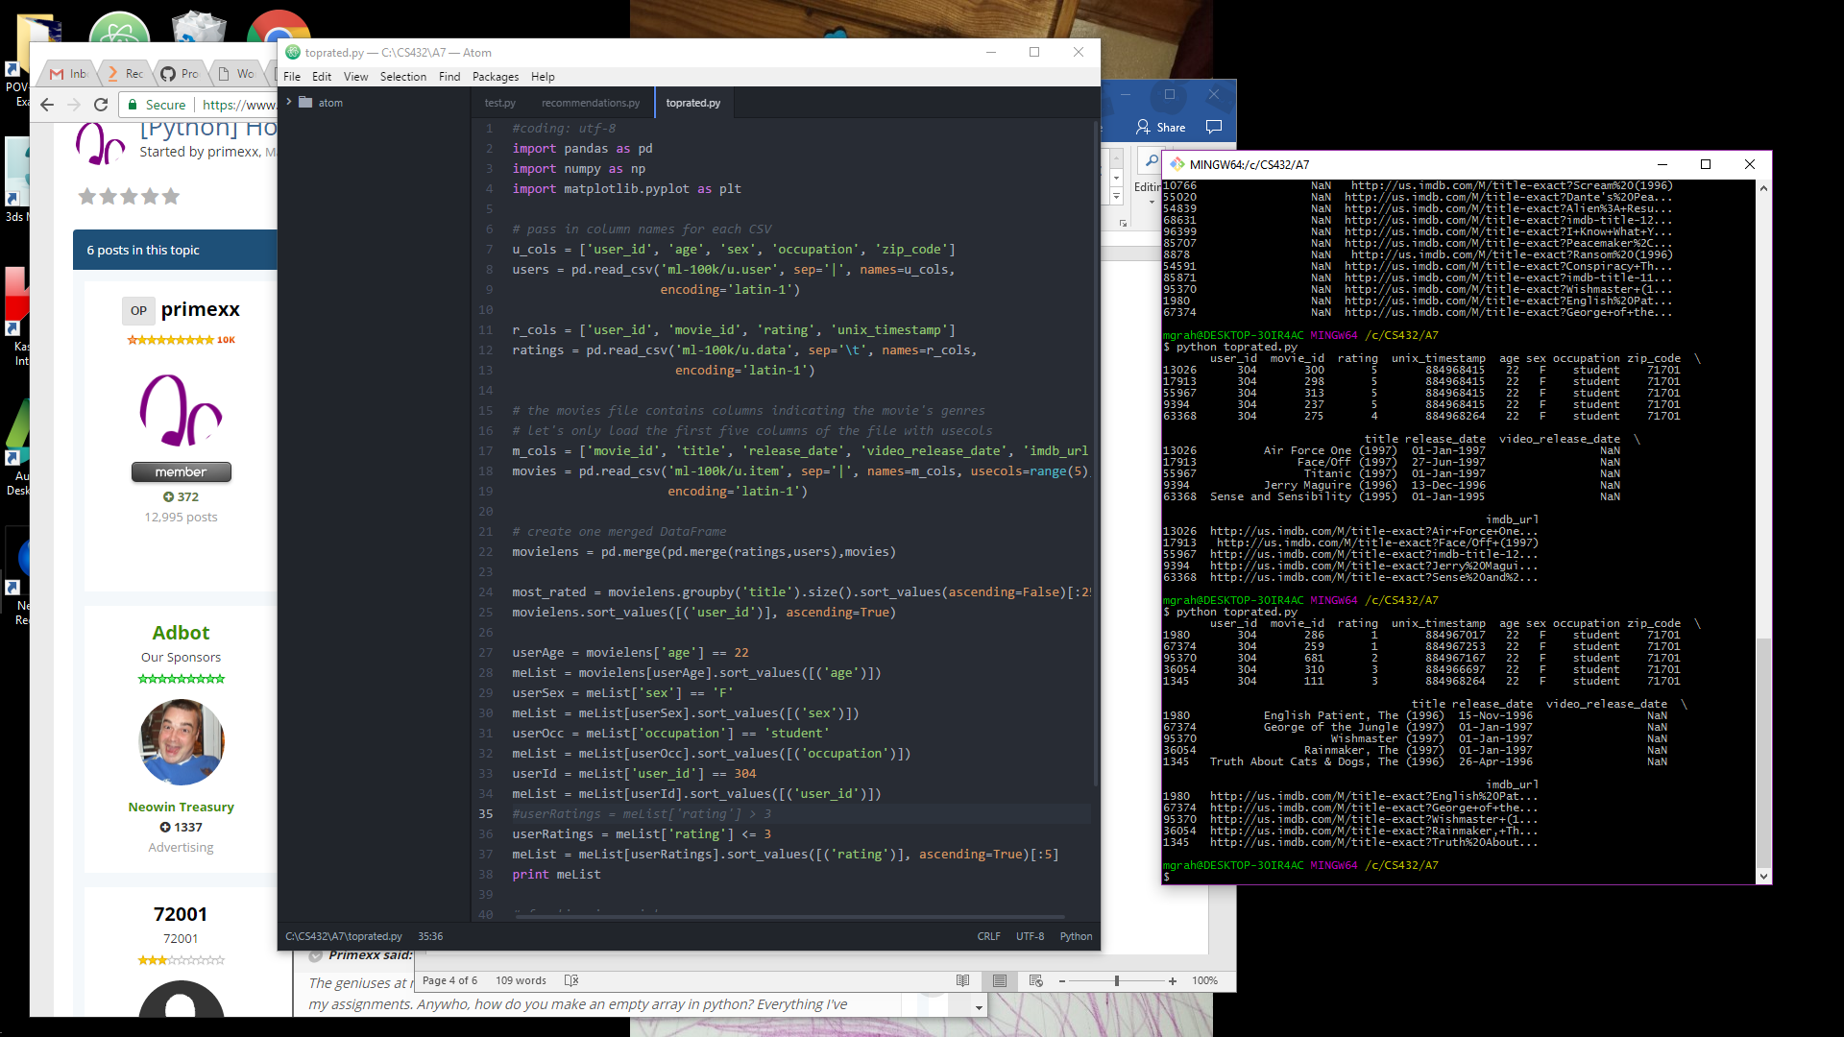



**User 304’s Bottom 5 Movies:**

Movie Rating

The English Patient (1996) 1

George of the Jungle (1997) 1

Wishmaster (1997) 2

The Rainmaker (1997) 3

The Truth About Cats & Dogs (1996) 3

My Top 5 Favorite Movies:

Movie Rating

Pulp Fiction 5

3 Ninjas: High Noon At Mega Mountain (1998) 5

The Empire Strikes Back (1980) 5

Return of the Jedi (1983) 5

Toy Story (1995) 5

Resources:

<https://github.com/arthur-e/Programming-Collective-Intelligence/blob/master/chapter2/recommendations.py>

<http://www.gregreda.com/2013/10/26/working-with-pandas-dataframes/>

<http://www.michaeltsmith.org.uk/ipython/Lesson%201,%20(detour)%20Python,%20pandas%20and%20Movie%20Ratings%20(MovieLens).html>

<https://www.packtpub.com/books/content/recommending-movies-scale-python>